FRENCHAY VILLAGE DESIGN STATEMENT
Questionnaire – Please complete

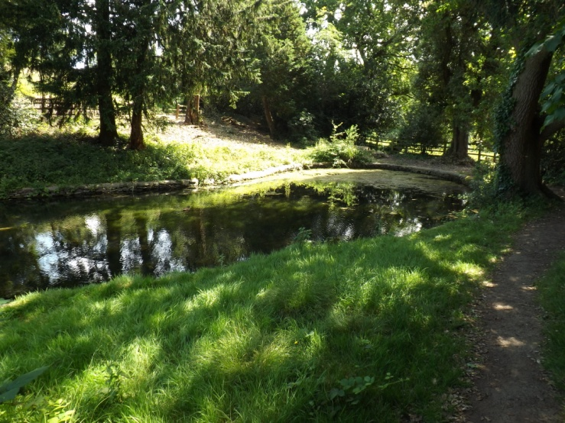

A public meeting was held at the Village Hall on Thursday 19th March to discuss and debate the proposed Village Design Statement (VDS). Part of Frenchay is covered by the Conservation status but areas outside such as Grange Park, Newlands, Riverwood and all properties outside the boundary are not. The VDS has proved to be a very useful tool to community’s around the country who have implemented one on all planning related matters including house type details as existing, boundary walls, gardens, lanes, parking, pavements, green areas, footpaths, trees etc.

If a measure of agreement emerges from the responses, the second stage will be to prepare a draft Village Design Statement and consult all residents about it. The document will provide a benchmark to define what is agreed as ‘appropriate and quality design’ for our village.

To enable this project to move forward we need your views as a resident. It would be helpful if you could complete this questionnaire by Sunday April 26th 2015 and return it to one of the addresses closest to you on the next page. Please scan and email if easier to mail@frenchaypreservation.info. Please answer questions in boxes below each section or please add and expand on another sheet.

Question 1
In your view, what specific physical characteristics are important to the current buildings/green space, design and character of the village? Feedback could be as follows -

. Open green spaces with fine landscape views and rural countryside feel to Frenchay.
. Period street lighting in places and design of many old and more recent properties
. Old Pennant stone walls

Question 2
In your view, how is the village changing, what pressures are there for change that might need care/control and what do you want to see change/improve? Feedback could be -

. Concerns over new house building in the future
. Increasing traffic at peak times and parking

Question 3
What particularly would you want to preserve and why? Feedback could be –

. Keep the unique feel and visual character of Frenchay
. The Village Hall, Tuckett Pond etc

Question 4
What other comments, if any, would you wish to make.

……………………………………………………………………………………………………………………………………………….
Please give your name and address

……………………………… Address ……………………………………………………………………………………………….

Please return to: Paul Kembery, Millwood House, Tuckett Lane, Frenchay Hill. BS16 1LU. Or
Eurof Lewis, 5, Grange Park, Frenchay. BS16 2SZ.
Please scan and email if easier to mail@frenchaypreservation.info.

This questionnaire has been initiated by Frenchay Preservation Society and printed by Winterbourne Parish Council. Your comments will only be used in a general context and will not be published verbatim unless permission is given.

