BUS STOP USAGE

A4174, Hambrook westbound

A Reminder that this is a permanent arrangement

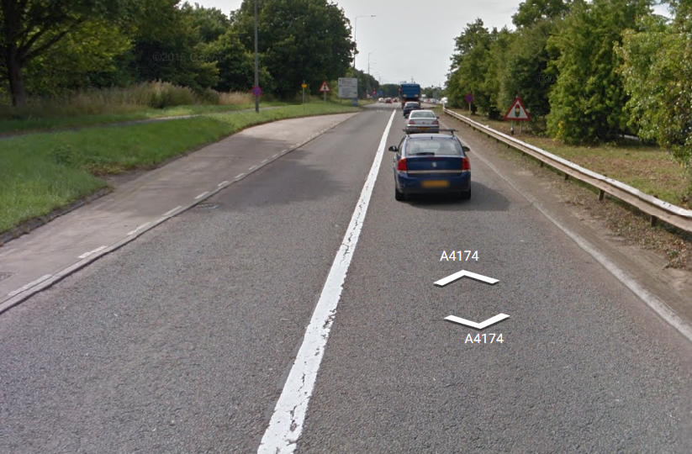
Services 18, 18A, 19, X47 & X48 to use new stop on A4174 prior to Hambrook junction
Note: this is a permanent stop

If you are unsure about this diversion, please contact a member of your Depot Management Team prior to commencement of your duty.

